**Android App Testing Screenshots**

Forgot Reset Password

Row No.: 2

|  |  |  |  |  |
| --- | --- | --- | --- | --- |
| **Description** | **Test Steps** | **Expected Output** | **Status** | **Comments** |
| Verify accessibility of Forgot Password link | 1. Navigate to the receptionist login page 2. Locate the 'Forgot Password' link 3. Click on the 'Forgot Password' link | 1. The 'Forgot Password' link should be clearly visible on the login page 2. The link should be clickable 3. User should be redirected to the password recovery page | **Fail** | 'Forgot Password' link is clearly visible and clickable.  But, gives the error ‘Something went wrong’ |

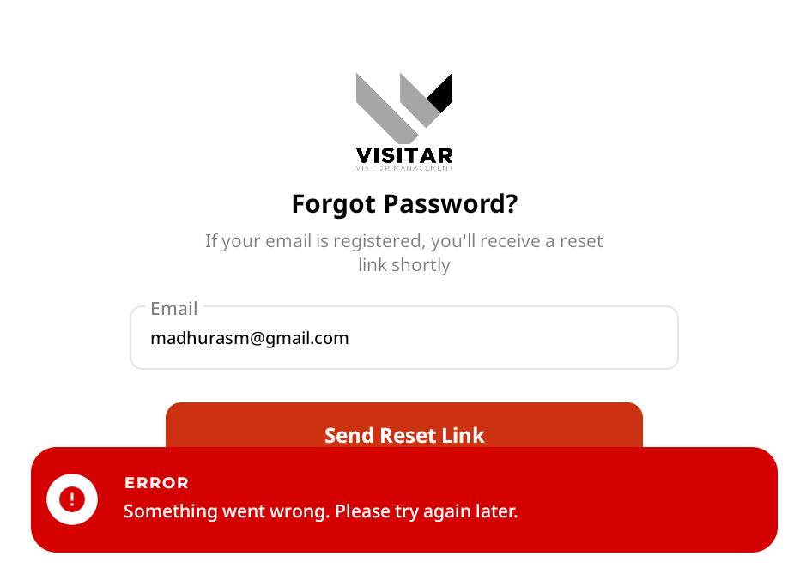

Row No.: 7

|  |  |  |  |  |
| --- | --- | --- | --- | --- |
| **Description** | **Test Steps** | **Expected Output** | **Status** | **Comments** |
| Verify submitting with a valid registered email | 1. Navigate to the forgot password page 2. Enter a valid email that is registered in the system 3. Click the submit button | 1. A success message should appear saying 'If the email exists in our system, a password reset link has been sent' 2. A password reset link should be sent to the provided email address 3. The email should be received within a reasonable time frame | **Fail** | When a valid email is entered and Send Reset Link button is clicked, it gives the error message 'Something went wrong. Please try again later' |

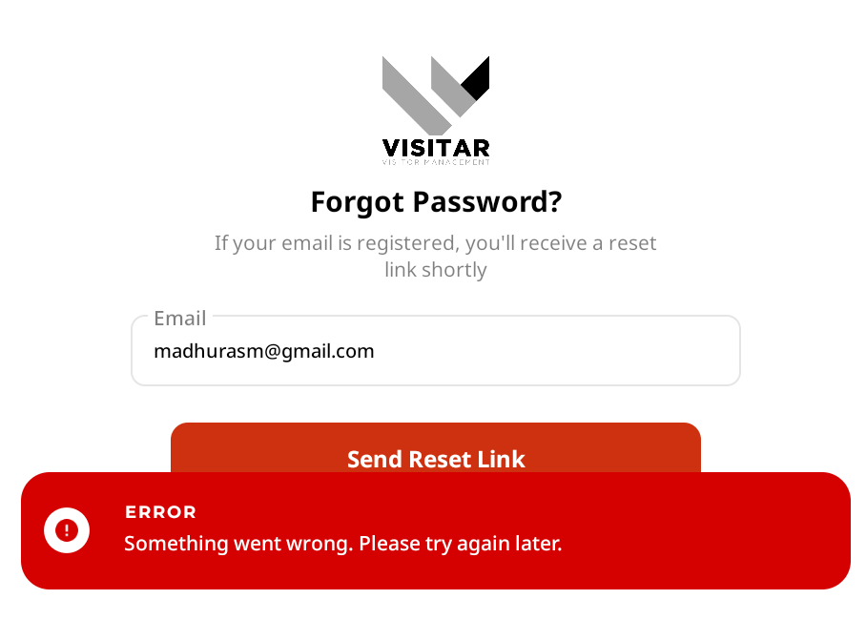

Row No.: 8

|  |  |  |  |  |
| --- | --- | --- | --- | --- |
| **Description** | **Test Steps** | **Expected Output** | **Status** | **Comments** |
| Verify multiple password reset requests for the same email | 1. Navigate to the forgot password page 2. Enter a valid registered email 3. Submit the form 4. Repeat steps 1-3 within a short time period | 1. System should handle multiple requests without errors 2. Either:  - New reset links should be sent, invalidating previous ones, or  - A message should indicate that a reset link was recently sent and to check email or wait before requesting again | **Fail** | When a valid email is entered and Send Reset Link button is clicked multiple times within a short time period, it gives the error message 'Something went wrong. Please try again later' every time |



Row No.: 10

|  |  |  |  |  |
| --- | --- | --- | --- | --- |
| **Description** | **Test Steps** | **Expected Output** | **Status** | **Comments** |
| Verify forgot password with special characters in email | 1. Navigate to the forgot password page 2. Enter a valid email containing special characters (e.g., test.user+tag@domain.com) 3. Submit the form | 1. System should handle special characters in email correctly 2. Password reset process should be initiated successfully | **Fail** | When a valid email address containing special characters is entered, it gives the error message ‘The selected email is invalid’ |

